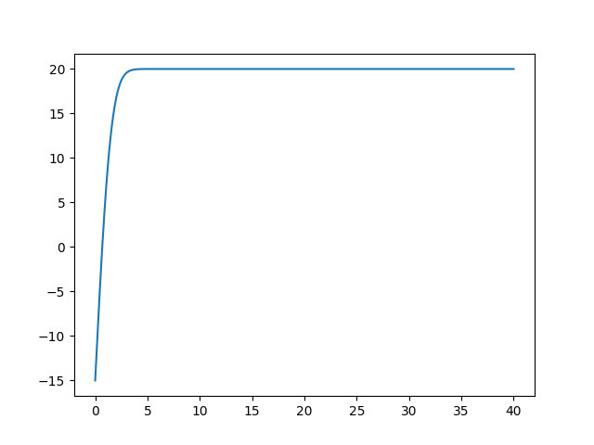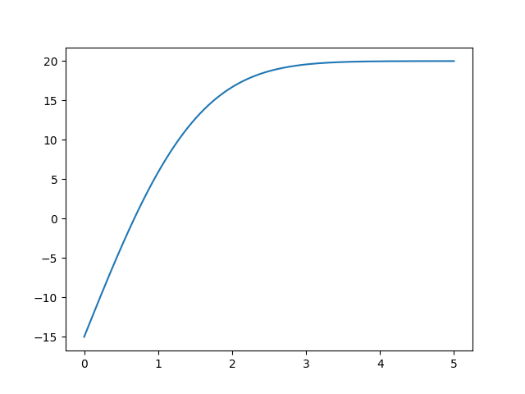Problem 1: (xbar = 5 in the plot on the right, but in the computation xbar = 1)

Problem 5:

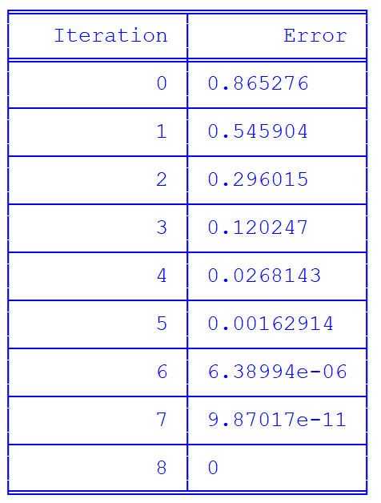Newton’s Method:

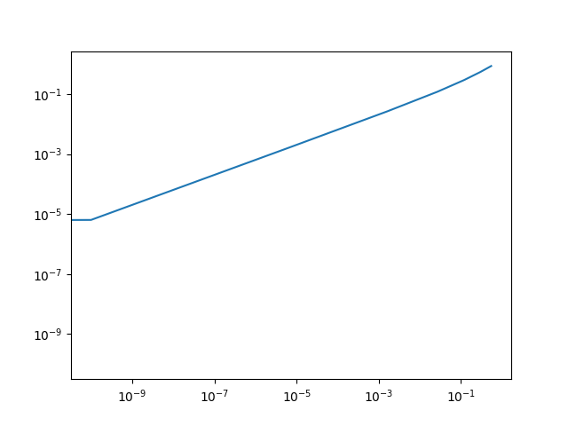

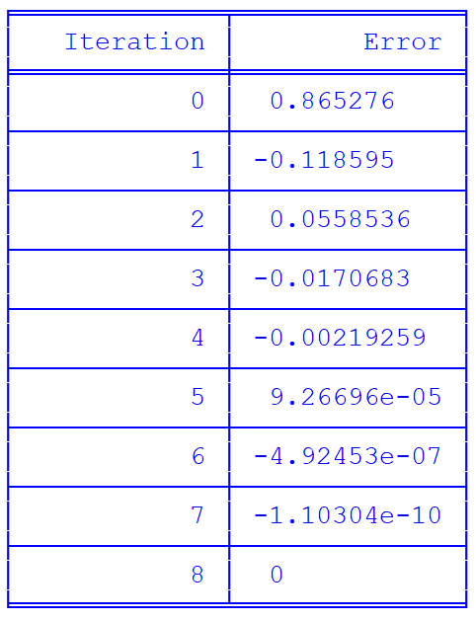Secant Method:

The errors in the tables decreases, just as you would expect, for both newton’s method and the secant method. The order of convergence is the same as the slope of the log graphs above for each method.